**CSS ID, Class and Tags**

1. First thing is to copy this text on notepad, we are using the following paragraph to demonstrate CSS and HTML:

Told against the backdrop of the changing political landscape of Afghanistan from the 1970s to the period following 9/11, The Kite Runner is the story of the unlikely and complicated friendship between Amir, the son of a wealthy merchant, and Hassan, the son of his father’s servant until cultural and class differences and the turmoil of war tear them asunder. Hosseini brings his homeland to life for us in a way that post 9/11 media coverage never could, showing us a world of ordinary people who live, die, eat, pray, dream, and love. It’s a story about the long shadows that family secrets cast across decades, the enduring love of friendship, and the transformative power of forgiveness.

1. Complete the CSS and HTML snippet code to demonstrate the HTML output on the web browswer.

--------------------------------------------------------------------------------------------------------------------------------------

Exercise 1.

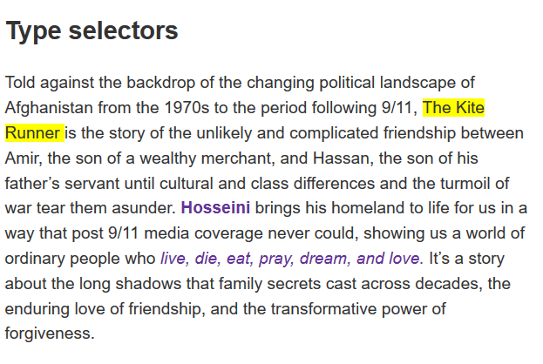

**CSS code goes here:**

**HTML code goes here:**

Exercise 2. - **The universal selector**

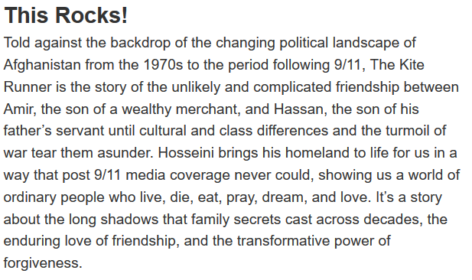

**CSS code goes here:**

**HTML code goes here:**

## Exercise 3. - Class selectors

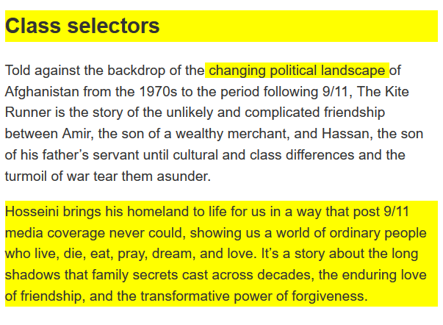

**CSS code goes here:**

**HTML code goes here:**

### Exercise 4. - Targetting classes on particular elements

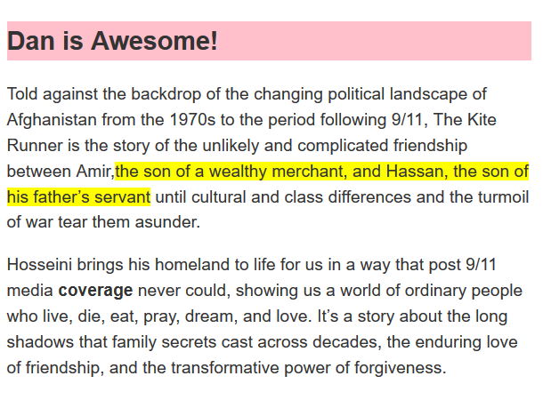

**CSS code goes here:**

**HTML code goes here:**

Exercise 5 - ID Selectors

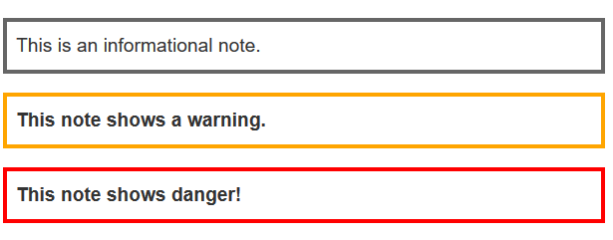

**CSS code goes here:**

.notebox{

border: 4px solid #666;

padding:0.5em;

}

.notebox.warning{

border: 4px solid #FF8600;

padding:0.5em;

font-weight:bold;

}

.notebox.danger{

border: 4px solid #FF0004;

padding: .5em;

font-weight: bold;

}

**HTML code goes here:**

<div class= "notebox">

This is informational note

</div>

<br>

<div class = "notebox warning">

This note shown warning.

</div>

<br>

<div class = "notebox danger">

This note shows danger!

</div>

## Exercise 6. ID Selectors

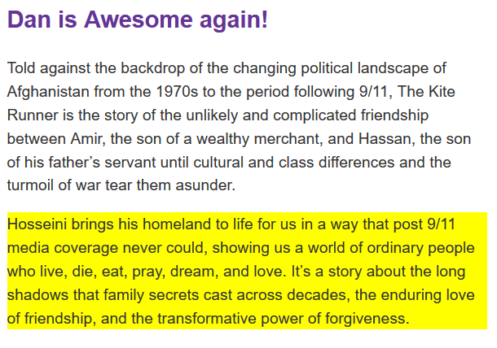

**CSS code goes here:**

h1#headline{

color: purple;

}

p#one{

background-color:yellow;

}

**HTML code goes here:**

<h1 id= "headline"> Dan is Awesome Again!</h1>

Told against the backdrop of the changing political landscape of Afghanistan from the 1970s to the period following 9/11, The Kite Runner is the story of the unlikely and complicated friendship between Amir, the son of a wealthy merchant, and Hassan, the son of his father’s servant until cultural and class differences and the turmoil of war tear them asunder.

<p id= "one">Hosseini brings his homeland to life for us in a way that post 9/11 media coverage never could, showing us a world of ordinary people who live, die, eat, pray, dream, and love. It’s a story about the long shadows that family secrets cast across decades, the enduring love of friendship, and the transformative power of forgiveness.</p>